M WORSHIP

FIFTH SUNDAY IN LENT

*The Raising of Lazarus,* John Reilly, 1962

MARCH 26, 2023



***Peace Lutheran Church West Seattle, Washington***

***Welcome to Peace – your presence here enriches our community.***

*In today’s gospel Jesus reveals his power over death by raising Lazarus from the dead. The prophet Ezekiel prophesies God breathing new life into dry bones. To those in exile or living in the shadows of death, these stories proclaim God’s promise of resurrection. In baptism we die with Christ that we might also be raised with him to new life.*

🞤 🞤 🞤

*A pastoral sabbatical for Pastor Erik Kindem begins tomorrow with his personal retreat at the Trappist Abbey in Carlton, Oregon. He will then spend Holy Week with the Benedictine Community in Mt. Angel, Oregon. Meanwhile, the rest of the Kindem family will remain engaged in the life of Peace until the week following Easter, when they will reunite with him.*

*Pastor Paul Winterstein, our preacher today, will serve as Sabbatical Pastor while Pastor Kindem is away. Pastor Chelsea Globe will serve as Preacher and Presider for Palm Sunday and Easter.*

**🞤 GATHERING 🞤**

P – *Presider* A – *Assisting Minister* C **–** *Congregation* L *- Lector*

ELW *– Evangelical Lutheran Worship Hymnal*

**PRELUDE**

WELCOME

**GATHERING HYMN** ***Awake, O Sleeper, Rise from Death* ELW #452**

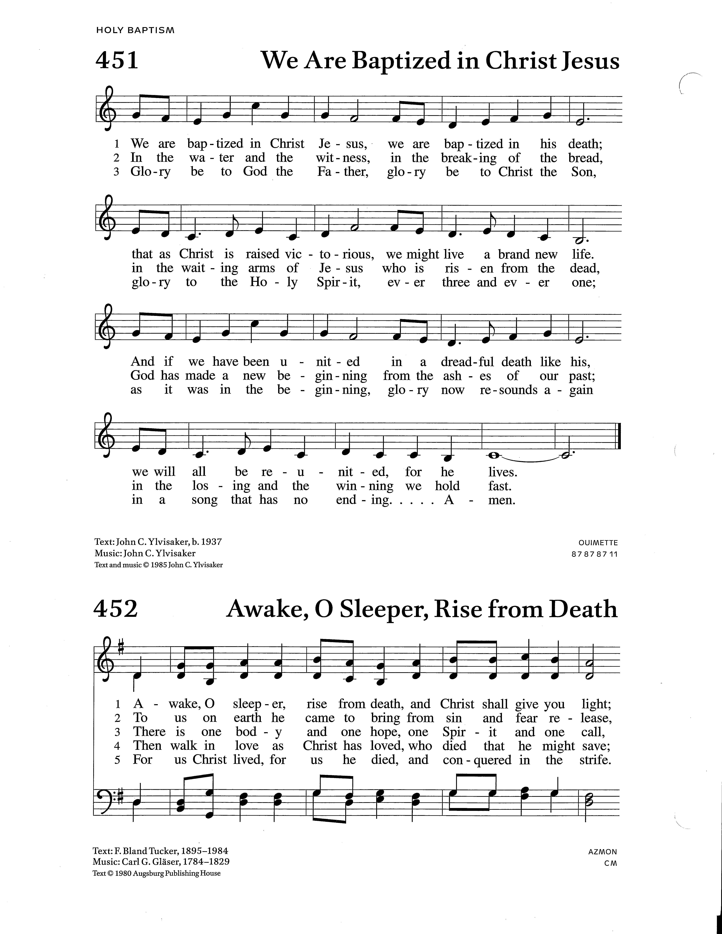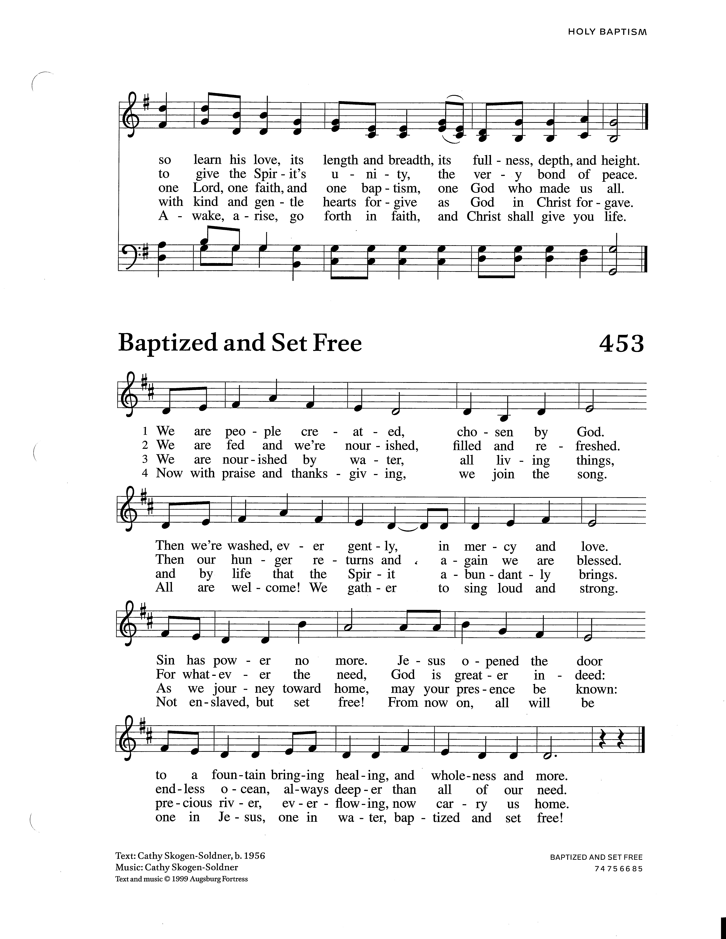

**GREETING**

P The grace of our Lord Jesus Christ, the love of God,

and the communion of the Holy Spirit be with you all.

**C And also with you.**

**KYRIE** *The Cantor leads the Kyrie and the congregation responds with “Lord, have mercy.”*

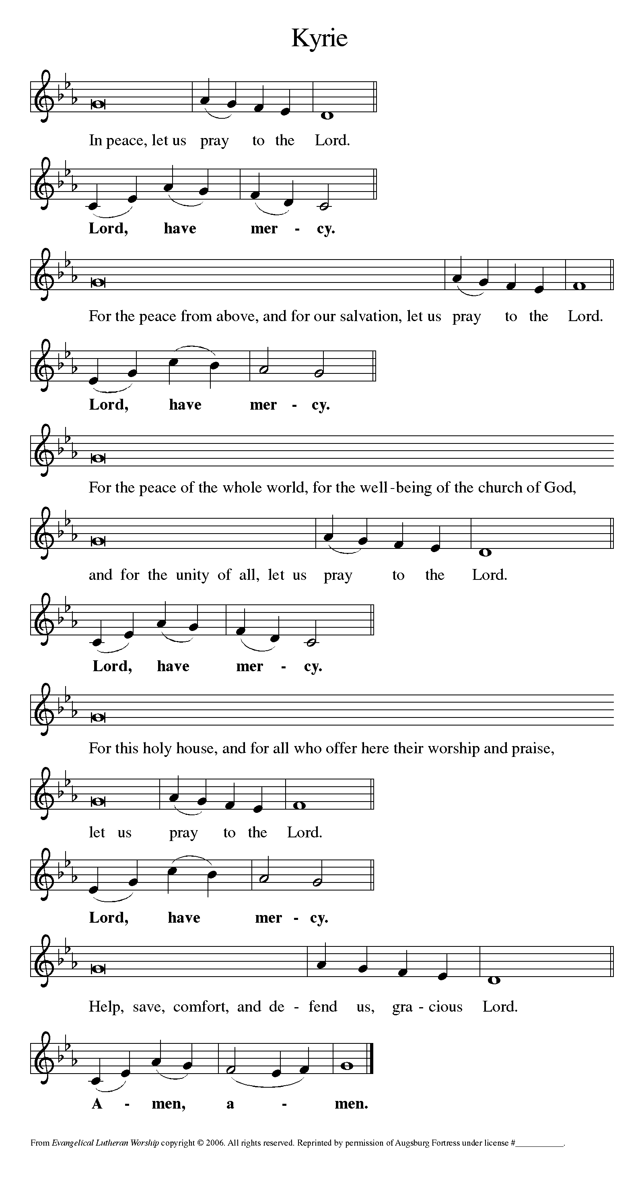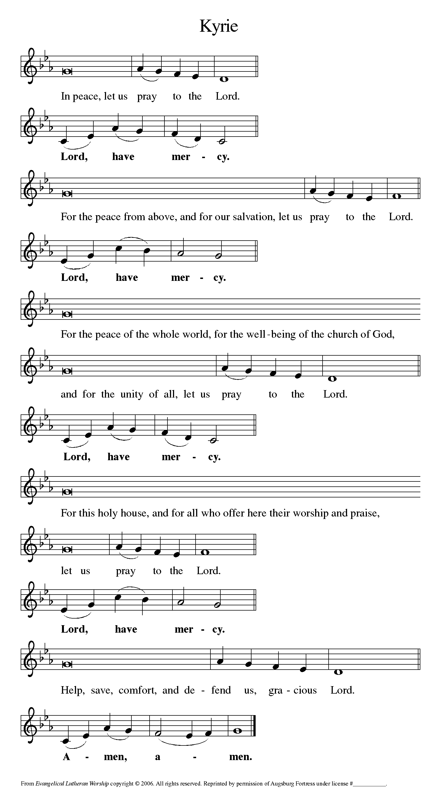

**PRAYER OF THE DAY**

P  The Lord be with you.

**C And also with you.**

P  Let us pray. Almighty and Altender God, your Son came into the world to free us all from sin and death. Breathe upon us the power of your Spirit, that we may be raised to new life in Christ and serve you in righteousness all our days, through Jesus Christ, our Savior and Lord, who lives and reigns with you and Holy Spirit, on God, now and forever.

**C Amen.**

**🞤 WORD 🞤**

**FIRST READING:** **Ezekiel 37:1-14** David Wold

*Ezekiel’s vision of the valley of dry bones is a promise that Israel as a nation, though dead in exile, will live again in their land through God’s life-giving spirit. Three times Israel is assured that through this vision they will know that “I am the Lord.”*

The hand of the LORD came upon me, and he brought me out by the spirit of the LORD and set me down in the middle of a valley; it was full of bones. 2He led me all around them; there were very many lying in the valley, and they were very dry. 3He said to me, "Mortal, can these bones live?" I answered, "O Lord GOD, you know." 4Then he said to me, "Prophesy to these bones, and say to them: O dry bones, hear the word of the LORD. 5Thus says the Lord GOD to these bones: I will cause breath to enter you, and you shall live. 6I will lay sinews on you, and will cause flesh to come upon you, and cover you with skin, and put breath in you, and you shall live; and you shall know that I am the LORD."

7So I prophesied as I had been commanded; and as I prophesied, suddenly there was a noise, a rattling, and the bones came together, bone to its bone. 8I looked, and there were sinews on them, and flesh had come upon them, and skin had covered them; but there was no breath in them. 9Then he said to me, "Prophesy to the breath, prophesy, mortal, and say to the breath: Thus says the Lord GOD: Come from the four winds, O breath, and breathe upon these slain, that they may live." 10I prophesied as he commanded me, and the breath came into them, and they lived, and stood on their feet, a vast multitude.

11Then he said to me, "Mortal, these bones are the whole house of Israel. They say, 'Our bones are dried up, and our hope is lost; we are cut off completely.' 12Therefore prophesy, and say to them, Thus says the Lord GOD: I am going to open your graves, and bring you up from your graves, O my people; and I will bring you back to the land of Israel. 13And you shall know that I am the LORD, when I open your graves, and bring you up from your graves, O my people. 14I will put my spirit within you, and you shall live, and I will place you on your own soil; then you shall know that I, the LORD, have spoken and will act," says the LORD.

L The Word of the Lord.

**C Thanks be to God.**

**PSALMODY 130** Marty Haugen

*The congregation joins the choir on each refrain.*



1. From out of the depths, I cry unto you, Lord, hear my voice, come hear my prayer;

O let your ear by open to my pleading. (***Refrain)***

2. If you, O Lord, should mark our guilt, then who could stand within your sight?

But in you is found forgiveness for our failings. ***(Refrain)***

3. Just as those who wait for the morning light, even more I long for the Lord, my God,

whose word to me shall ever be my comfort. ***(Refrain)***

**LENTEN ACCLAMATION** *Please rise in body or spirit to receive the gospel.*

P The Holy Gospel according to John, the 11th Chapter.

**C Glory to you, O Lord.**

**GOSPEL: John 11:1-45**

*Jesus is moved to sorrow when his friend Lazarus falls ill and dies.*

*Then, in a dramatic scene, he calls his friend out of the tomb and restores him to life.*

Now a certain man was ill, Lazarus of Bethany, the village of Mary and her sister Martha. 2Mary was the one who anointed the Lord with perfume and wiped his feet with her hair; her brother Lazarus was ill. 3So the sisters sent a message to Jesus, "Lord, he whom you love is ill." 4But when Jesus heard it, he said, "This illness does not lead to death; rather it is for God's glory, so that the Son of God may be glorified through it." 5Accordingly, though Jesus loved Martha and her sister and Lazarus, 6after having heard that Lazarus was ill, he stayed two days longer in the place where he was.

7Then after this he said to the disciples, "Let us go to Judea again." 8The disciples said to him, "Rabbi, the Jews were just now trying to stone you, and are you going there again?" 9Jesus answered, "Are there not twelve hours of daylight? Those who walk during the day do not stumble, because they see the light of this world. 10But those who walk at night stumble, because the light is not in them." 11After saying this, he told them, "Our friend Lazarus has fallen asleep, but I am going there to awaken him." 12The disciples said to him, "Lord, if he has fallen asleep, he will be all right." 13Jesus, however, had been speaking about his death, but they thought that he was referring merely to sleep. 14Then Jesus told them plainly, "Lazarus is dead. 15For your sake I am glad I was not there, so that you may believe. But let us go to him." 16Thomas, who was called the Twin, said to his fellow disciples, "Let us also go, that we may die with him."

17When Jesus arrived, he found that Lazarus had already been in the tomb four days. 18Now Bethany was near Jerusalem, some two miles away, 19and many of the Jews had come to Martha and Mary to console them about their brother. 20When Martha heard that Jesus was coming, she went and met him, while Mary stayed at home. 21Martha said to Jesus, "Lord, if you had been here, my brother would not have died. 22But even now I know that God will give you whatever you ask of him." 23Jesus said to her, "Your brother will rise again." 24Martha said to him, "I know that he will rise again in the resurrection on the last day." 25Jesus said to her, "I am the resurrection and the life. Those who believe in me, even though they die, will live, 26and everyone who lives and believes in me will never die. Do you believe this?" 27She said to him, "Yes, Lord, I believe that you are the Messiah, the Son of God, the one coming into the world."

28When she had said this, she went back and called her sister Mary, and told her privately, "The Teacher is here and is calling for you." 29And when she heard it, she got up quickly and went to him. 30Now Jesus had not yet come to the village, but was still at the place where Martha had met him. 31The Jews who were with her in the house, consoling her, saw Mary get up quickly and go out. They followed her because they thought that she was going to the tomb to weep there. 32When Mary came where Jesus was and saw him, she knelt at his feet and said to him, "Lord, if you had been here, my brother would not have died." 33When Jesus saw her weeping, and the Jews who came with her also weeping, he was greatly disturbed in spirit and deeply moved. 34He said, "Where have you laid him?" They said to him, "Lord, come and see." 35Jesus began to weep. 36So the Jews said, "See how he loved him!" 37But some of them said, "Could not he who opened the eyes of the blind man have kept this man from dying?"

38Then Jesus, again greatly disturbed, came to the tomb. It was a cave, and a stone was lying against it. 39Jesus said, "Take away the stone." Martha, the sister of the dead man, said to him, "Lord, already there is a stench because he has been dead four days." 40Jesus said to her, "Did I not tell you that if you believed, you would see the glory of God?" 41So they took away the stone. And Jesus looked upward and said, "Father, I thank you for having heard me. 42I knew that you always hear me, but I have said this for the sake of the crowd standing here, so that they may believe that you sent me." 43When he had said this, he cried with a loud voice, "Lazarus, come out!" 44The dead man came out, his hands and feet bound with strips of cloth, and his face wrapped in a cloth. Jesus said to them, "Unbind him, and let him go."

45Many of the Jews therefore, who had come with Mary and had seen what Jesus did, believed in him.

L The Gospel of the Lord.

**C Praise to you, O Christ.**

**CHOIR ANTHEM**

**CHILDREN’S TIME** Melanie Coulson

**SERMON** Pastor Paul Winterstein

**HYMN OF THE**  ***There in God’s Garden***     **ELW #342**

**PRAYERS OF INTERCESSION** Larry Cruse

A Sustained by God’s abundant mercy, let us pray for the church, the world,

and all creation.

*Petitions are offered, ending with the response:*

A Merciful God,

**C receive our prayer**

*When all petitions have been offered:*

P We lift our prayers to you, O God, trusting in your steadfast love and your promise to renew your whole creation; through Jesus Christ our Savior.

**C Amen.**

**🞤 MEAL 🞤**

**THE PEACE**

P The peace of the Lord be with you always.

**C And also with you.**

**ANNOUNCEMENTS**

**OFFERING**

*Your financial gifts today support the ongoing ministry of our congregation, cooperative ventures of ELCA congregations throughout Western Washington, and Evangelical Lutheran ministries around the world. We invite you to give generously! You can place your gift in the offering plate, mail in a check, or connect to our secure* [*Tithely Giving Page*](https://tithe.ly/give_new/www/#/tithely/give-one-time/300703) *via this QR CODE. Whatever size, your gift makes difference—thank you for your support!*

**OFFERTORY HYMN *We Raise Our Hands to You, O Lord* ELW #690**

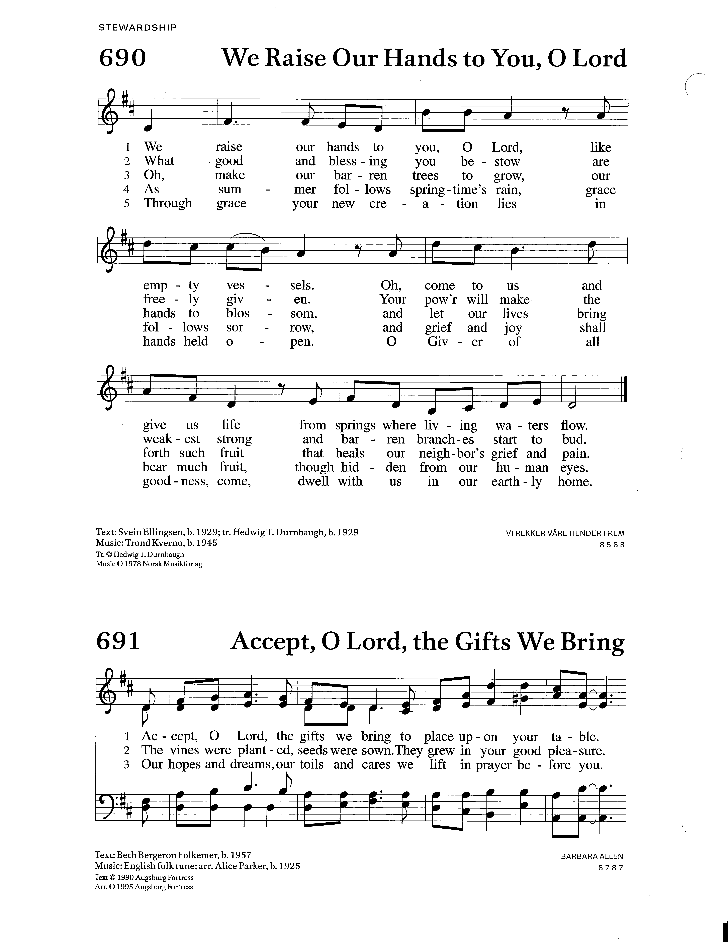

**OFFERTORY PRAYER**

A Let us pray. God of good gifts,

**C receive these gifts sand all our offerings, as we present them in faithful service**

**for the sake of your gospel. Prepare our hearts to receive you in this meal**

**as you pour out your very presence through Christ Jesus,**

**the wellspring of eternal life. Amen.**

**THE GREAT THANKSGIVING**

P ♪ *It is indeed right, our duty and our joy, that we should at all times and in all places*

*give thanks and praise…we praise your name and join their unending hymn:*

**HOLY, HOLY, HOLY**

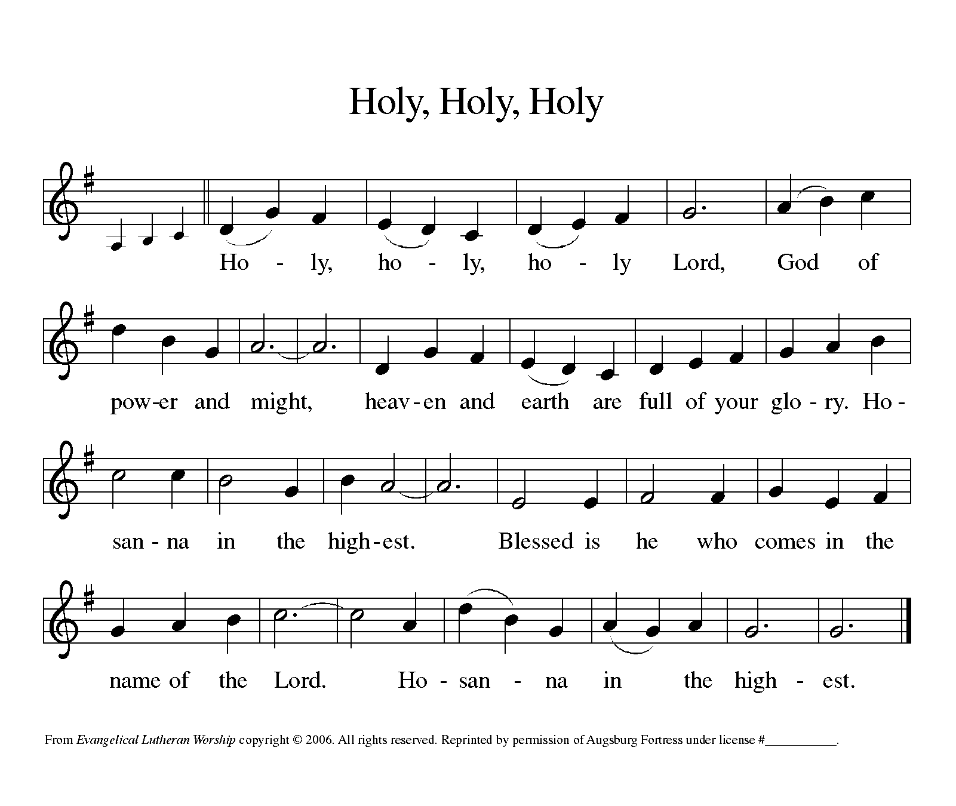

**EUCHARISTIC PRAYER**

**THE LORD’S PRAYER** *(ecumenical)*

**Our Father in heaven, hallowed be your name,**

**your kingdom come, your will be done on earth as in heaven.**

**Give us today our daily bread.**

**Forgive us our sins as we forgive those who sin against us.**

**Save us from the time of trial and deliver us from evil.**

**For the kingdom, the power, and the glory are yours,**

**now and forever. Amen.**

**INVITATION TO COMMUNION**

P Come receive Jesus, our strength in the wilderness.

**C Thanks be to God.**

DISTRIBUTION

*Christ, our Host, meets us in this meal of grace and offers himself, fully embodied, in the bread and wine. He invites all to come and meet him in this Holy Meal. During Lent we commune at the rail, either kneeling or standing. Gluten free bread is available. Both wine (dark) and grape juice (light) are available in the ceramic cups. Place your empty cup in the box at the end of the front pew on your way back. Children are welcome to receive when their parents believe they are ready, with the support of the pastor. Any who prefer a blessing may cross their hands over their chest as they come forward.*

**LAMB OF GOD**

**COMMUNION HYMNS**

***Tree of Life and Awesome Mystery*** verses 1-3, Lent 5   **ELW #334**

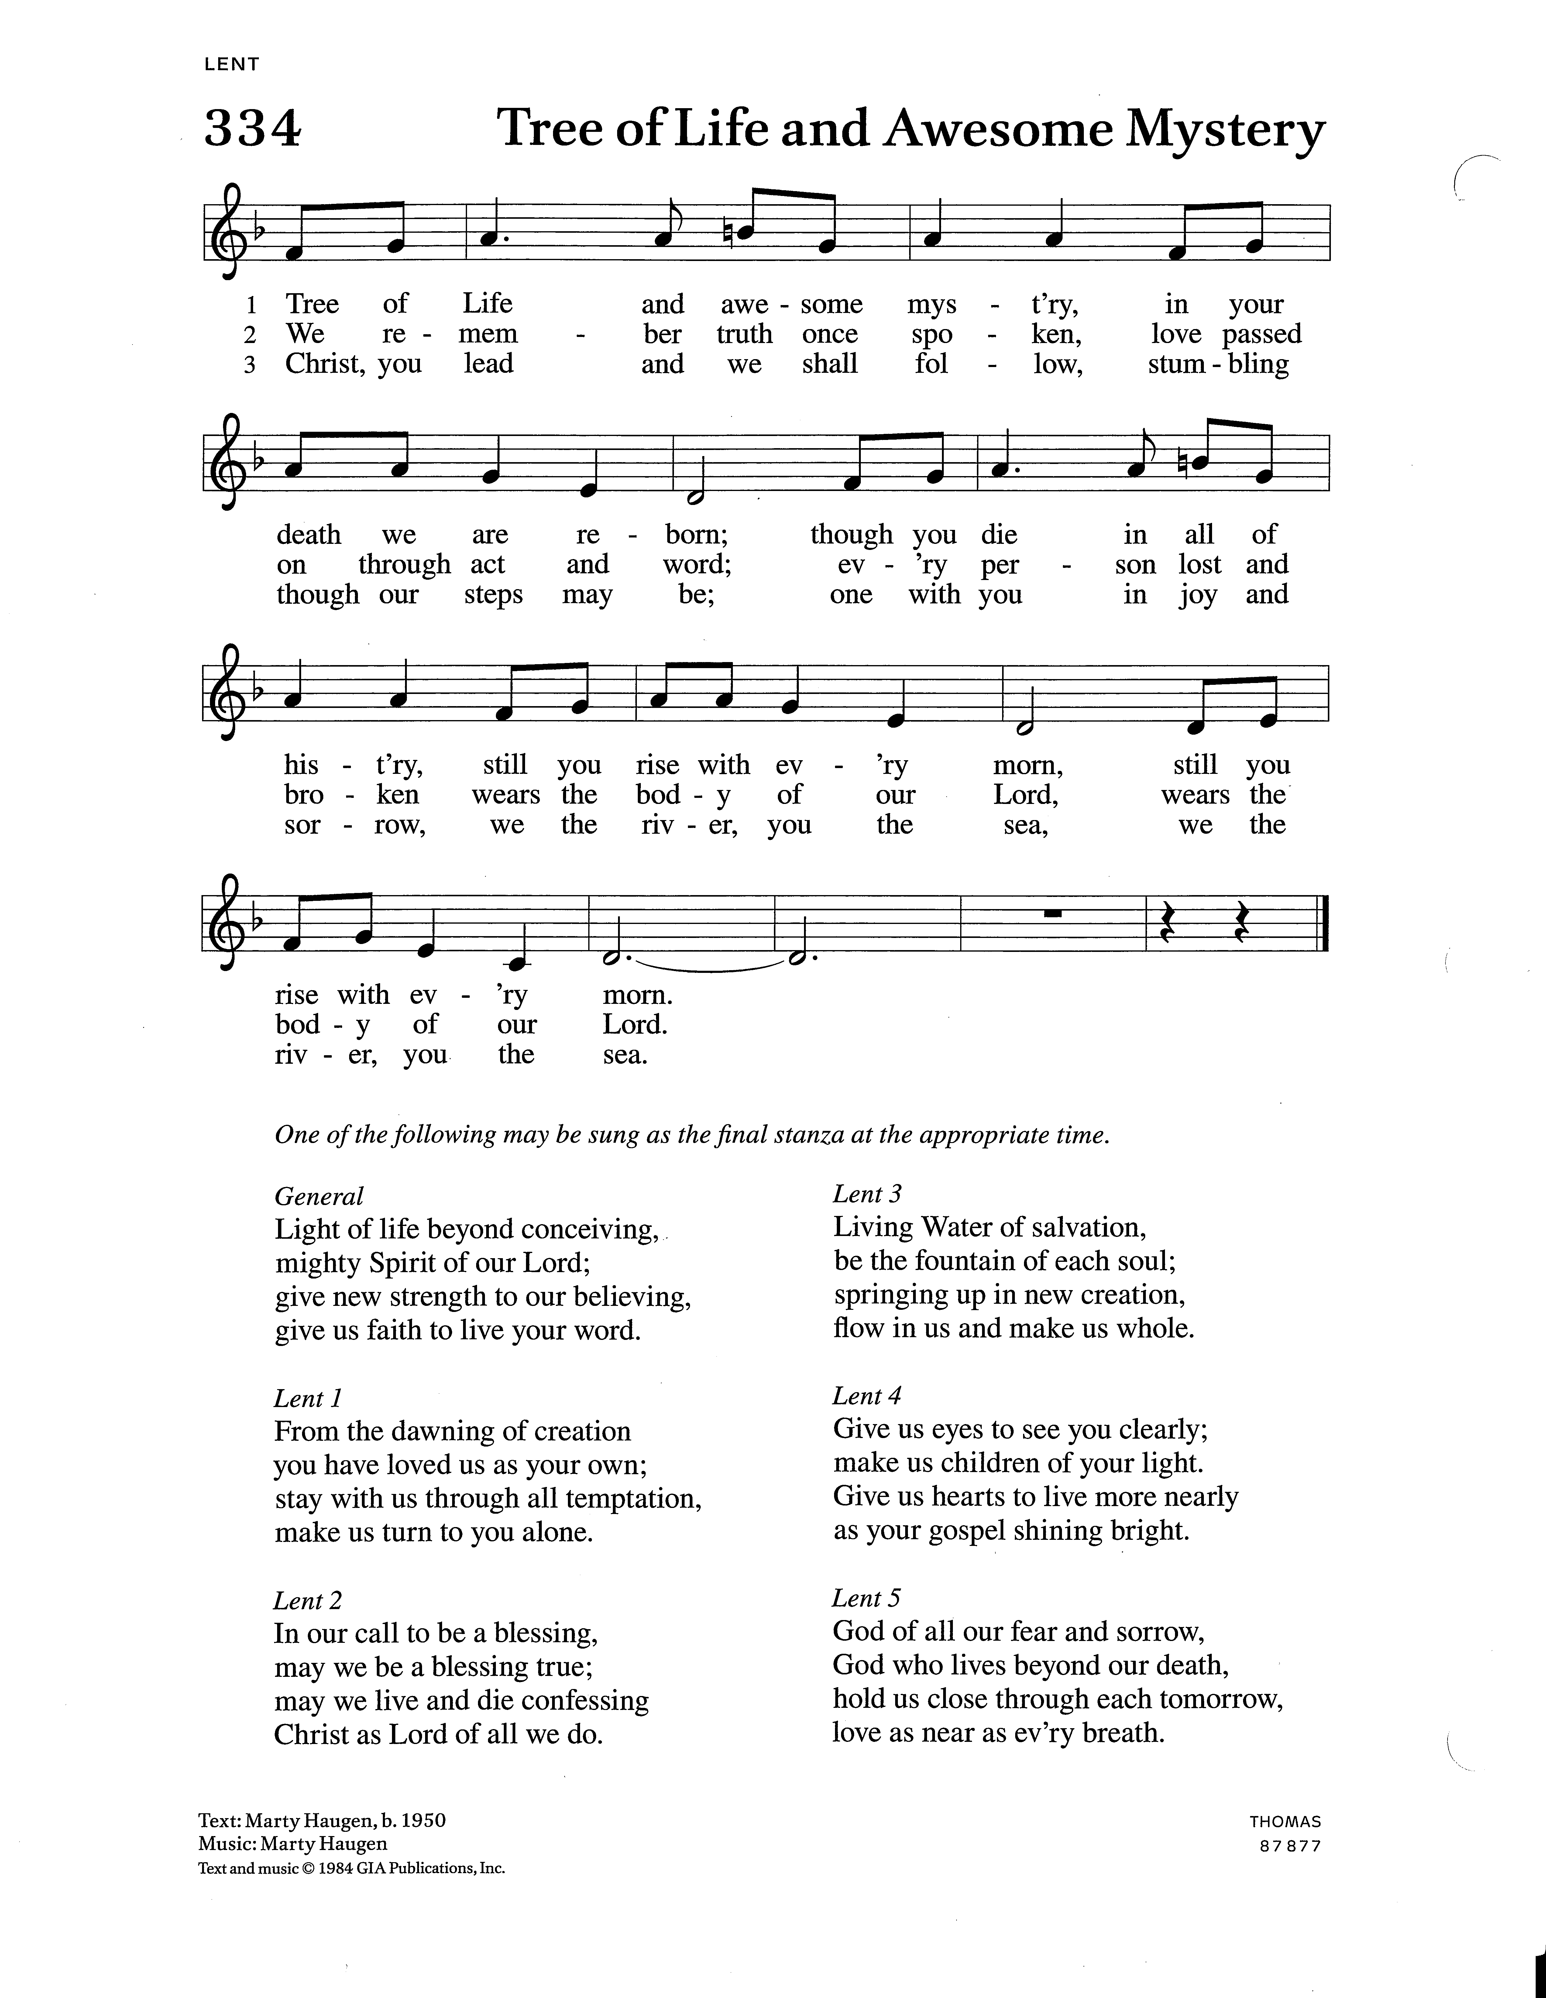

Lent 5 God of all our fears and sor - row, God who



lives be - yond our death, hold us close through each to-



mor - row, love as near as ev - ‘ry breath, love as



near as ev - ‘ry breath.

***By Your Hand You Feed Your People* ELW #469**









**POST-COMMUNION PRAYER**

A Let us pray. Embodied God, at your table, we have tasted the goodness of Jesus.

With the eyes of our hearts open to your promise, empower us to hear the needs

of our neighbors and touch the world with your love.

**C Amen.**

**🞤 SENDING 🞤**

**TRANSFER OF PASTORAL ROLE**

*Pastor Erik relinquishes his stole, a symbol of his pastoral office, for the duration of the sabbatical.*

**BLESSING & GODSPEED**

*All are invited to come forward as Pastor Erik, Chris, Kai & Naomi kneel for the laying on of hands and blessing. Those who remain seated are invited to extend a hand toward the Kindem family.*

P Erik, as you begin your journey of renewal, and Chris, Kai, and Naomi, as you prepare for the time when you will join him following Easter, our prayers and blessing go with you...

VENTURE PRAYER

P  Let us join together in the venture prayer.

**C O God, you have called your servants to ventures of which we cannot see the ending, by paths as yet untrodden, through perils unknown. Give us faith to go out with good courage, not knowing where we go, but only that your hand is leading us and your love supporting us, through Jesus Christ our Lord. Amen.**

CHORAL BLESSING *title*

SENDING HYMN Bret Hesla

*Give Us Bread for the Journey Verse 1, CHOIR, Verses 2-5, Congregation*

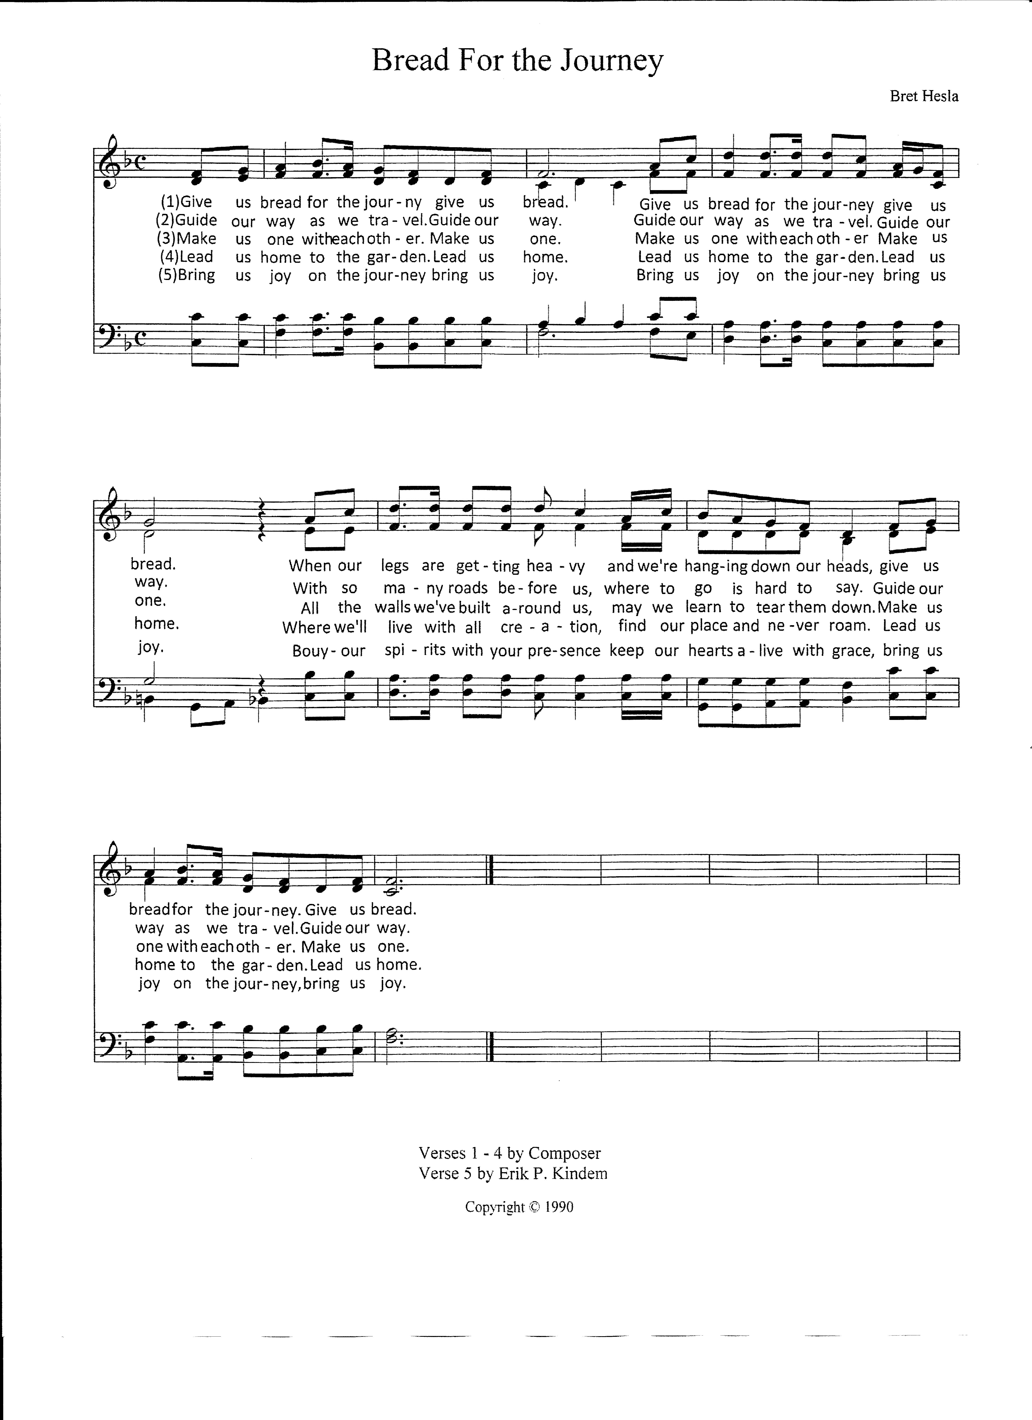

DISMISSAL

P Go in peace. Christ goes with you.

**C Thanks be to God.**

**POSTLUDE**

*Please join us downstairs in the fellowship hall for a … (get description from Heidi E.).*

**🞤 🞤 🞤**

**CONTACT INFORMATION**

8316 39th Avenue SW, Seattle, WA 98136 206-935-1962

Pastor Paul Winterstein mobile phone number:

Peace Lutheran web page: www.peacelutheranseattle.org

Kathleen Keyes Office Admin. Office@peacelutheranseattle.org

Church Office hours: Tuesday through Thursday 10:00am-4:00pm

Nicole Klinemeier, Youth Director 206-427-6496

Jon Lackey, Minister of Music Music@peacelutheranseattle.org

Find us on at **People of Peace Lutheran**

**SERVING IN WORSHIP**

Pastor Rev. Erik Kindem

Preacher Rev. Paul Winterstein

Assisting Minister Rev. Chelsea Globe

Minister of Music Jon Lackey

Liturgical Assistant Larry Cruse

Acolyte Jonah Shah

Lector David Wold

Children’s Sermon Melanie Coulson

Greeters Kathleen Keyes (host), Jean Sides

Ushers Alan Jarvimaki, Scott Sunde

Altar Care Chris Kindem

Communion Assistants Tyler & Elizabeth Menstell Coyle

Coffee Server Kathleen Keyes

Production Techs Joey DiJulio, Alex Wren

Counters Joey DiJulio, Tyler Menstell Coyle

Nursery Attendant Heidi Coy

**OUR FINANCIAL STEWARDSHIP**

*Our mission goal for 2023 anticipates receiving offering income of $25,819 each month.*

**Offering Income received MARCH 2023**

03/05/23 $ 2,431.00

03/12/23 $ 1,620.00

03/19/23 $ 1,107.00

electronic $ 9,850.74

**Total $16,202.74**

*Thank you for your gifts which support God’s mission at Peace,*

*in the larger community, and internationally through the ELCA*

**THIS WEEK’S ACT FOR CREATION**

Attend **today’s** workshop with Earth Ministry/WAIPL and learn about advocating for creation and environmental justice. Why environmental justice? A 2021 EPA report stated that Black and African Americans are 34% more likely to now live in areas with the highest projected increases in childhood asthma diagnoses from a 3.6°F rise in global warming, and 40% more likely to now live in areas with the highest projected increases in extreme temperature related deaths. Learn more from Princeton’s *Racial Disparities and Climate Change* project <https://psci.princeton.edu/tips/2020/8/15/racial-disparities-and-climate-change>.

**Pray for Creation:** We pray for the restoration of the West Duwamish Greenbelt and for the wildlife who make it their home.

**PALM/PASSION SUNDAY AND HOLY WEEK**

**On Wednesday, March 8th,** we continue our Wednesday Evening Soup Supper @ 6pm, followed by Evening Prayer from 7:00–7:30pm. Please join us! **Look for the Soup Supper Sign-up Sheet on the SIGN-IN TABLE in the narthex for how you can participate.**

**PRAYER LIST**

**Please continue to remember the sick and home-bound of our congregation and others who have sought our prayers**: **Sick/Recovering:** Kathy Anderson; Arlene; Mark Brocker; Vonda Cuchine; Marsha Davis; Grayson Eller; Mark Engelman; Deena Fuller; Jack Garrison; Caity Gerhardt; Nathaniel Gibson; Dawn Gringorten; Donna Heiland; Jerry Heiland; Garrison Hernandez; Heather Jennings; Victoria Johnson; Ken Keyes; Mike Larson; Noreen Lee; Dee Levy; Jan Madsen; RaeAnn Marrelli; Maya Marshall; Jack McBride; Chloe McDonough; Eric, Erin, Finley McDonough; Steve Metzler; Jim Meyer; Katrina Moore; Bill Morrell; Larry Nelson; Nora; Marianne Paulos; Paul Paulos; Michelle Pierce; Elaine Ross; Aaden Smith; Leon Smith; Charlie Spangler; JoAnne Spangler; Kadi Sue Sprengle; Sean Stephens; Sarah Taylor; Conrad Tollefson; Wade & Karin VanSant; Judy Wiggins; Inge Williams; Patti Wunder; Inta Zagars.

**Homebound**: Jim Baker; Connie Benjamin; Lee Lamson; Dorothy Linnell

**PROTOCOL FOR PRAYER LIST** We will keep people on the prayer list for one month unless otherwise specified or unless you contact the Peace office to extend the time.

**RECONCILING IN CHRIST AFFIRMATION OF WELCOME**

*Christ calls us to reconciliation and wholeness, in a world that can be filled with alienation and brokenness. In faithfulness to the Gospel and to our Lutheran heritage, we answer Christ’s call to be agents of healing and safety, particularly for people who have been marginalized by our society.*

*As a Christian community, we invite all people to join us as we work to better understand the meaning of grace for our lives. We welcome people of all sexual orientations and gender identities into the life and mission of our congregation.*

**PERMISSIONS**

**Liturgical excerpts** from Sundays and Seasons. © 2022 Augsburg Fortress. All rights reserved. Used by permission.

***Awake, O Sleeper, Rise from Death*** Text: F. Bland Tucker © 1980 Augsburg Publishing House. Music: Carl G. Gläser. Used by permission of OneLicense.net, License #A-708444, all rights reserved.

***Kyrie; Lenten Acclamation; Lamb of God; The Great Thanksgiving; Sanctus*** from setting 1 of Evangelical Lutheran Worship © 2006 Evangelical Lutheran Church in America. Published by Augsburg Fortress. Used by permission.

***Psalmody 130*** Text: Psalm 130: 1-2, 3-4, 5-6; Marty Haugen © 1983 GIA Publications, Inc.; refrain trans. © 1969, ICEL. Music: Marty Haugen © 1983 GIA Publications, Inc. Used by permission of OneLicense.net, License #A-708444, all rights reserved.

***Choir Anthem***

***Hymn of the Day***

***We Raise Our Hands to You, O Lord*** Text: Svein Ellingsen; tr. Hedwig T. Durnbaugh © Hedwig T. Durnbaugh. Music: Trond Kverno © 1978 Norsk Musikforlag. Used by permission of OneLicense.net, License #A-708444, all rights reserved.

***Tree of Life and Awesome Mystery*** Text and music: Marty Haugen © 1984 GIA Publications, Inc. Used by permission of OneLicense.net, License #A-708444, all rights reserved.

***By Your Hand You Feed Your People*** Text: Susan R. Briehl. Music: Marty Haugen. Text and music © 2002 GIA Publications, Inc. Used by permission of OneLicense.net, License #A-708444, all rights reserved.

***Choral Blessing***

***Give Us Bread for the Journey*** Text and music: Bret Hesla © 1990 Bret Hesla, admin. Augsburg Fortress. Used by permission of OneLicense.net, License #A-708444, all rights reserved.